Getting Online with Ngrok

- Before we can use Ngrok you will need to go to Blue Iris and click settings (the gear icon in top left). Under the “About” tab you should see your License key under registration. Please write down the first 5 and last 5 of this key for later use.
- Next click on the “Web Server” tab. If you haven’t already changed the port, change it from 81 to something like 8081. Write down your port for later use.
- Next write down the Local, internal (LAN) access address for later use.
- You will NOT need your Remote, external (WAN) address
- Now click on the Users tab. The default from us is username: admin and password: cc4455, either write that down or change it to whatever you like and write that down instead.
- By now you should have the following written down:
  - First and last 5 of key
  - Port
  - LAN address
  - Username and Password (default admin, cc4455)
- Now go to www.ngrok.com and click signup in the top right corner.
- Once you are signed up, it should take you to your dashboard. The first thing you will want to do is to download Ngrok. I would suggest downloading it to your desktop or documents folder, somewhere you can easily access it.
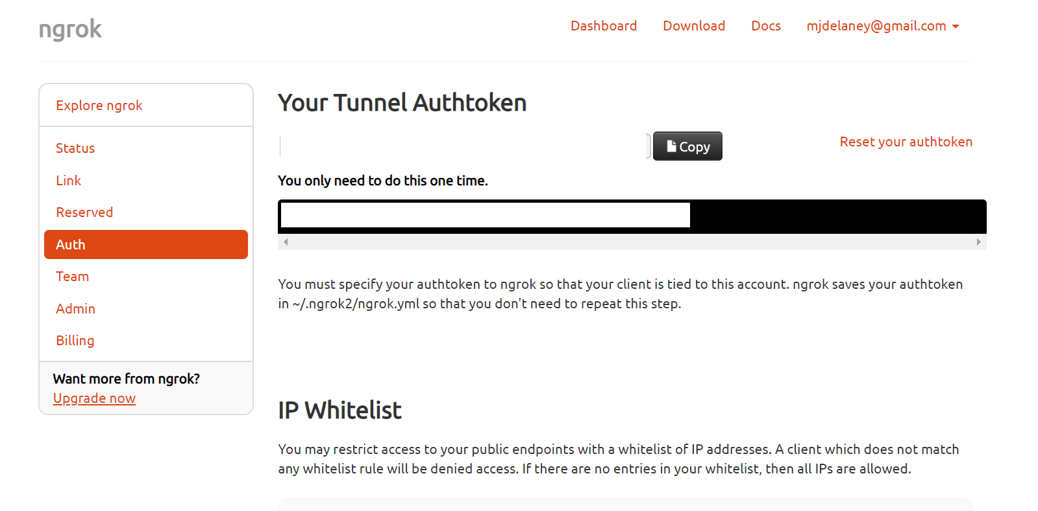
- Once you have the Ngrok program on your desktop go back to your Ngrok dashboard on your browser. Click on the “Auth” link on the left. This should bring up a page that looks like the below image. I have edited out my info.
- Click on the copy button to the right of “Your Tunnel Authtoken”
- Now go back to the Ngrok program on your desktop and double click it to open it. It should open up a dos style window.
- Type the following making sure to use the spaces, where I type control + V I just mean to hold control and P which will paste your Authtoken in. make sure you put a space after you type authtoken. If Control+V just shows an up arrow then V, then you will need to delete that and then right click, and click paste.
ngrok authtoken control + V
- It should let you know that it has been authorized for your account. If not then you may need to put your Ngrok program somewhere else, such as in your C drive. Once you have it there open it again, and it should work this time. You can create a shortcut for ngrok on your desktop if you would like to make it easier to access.
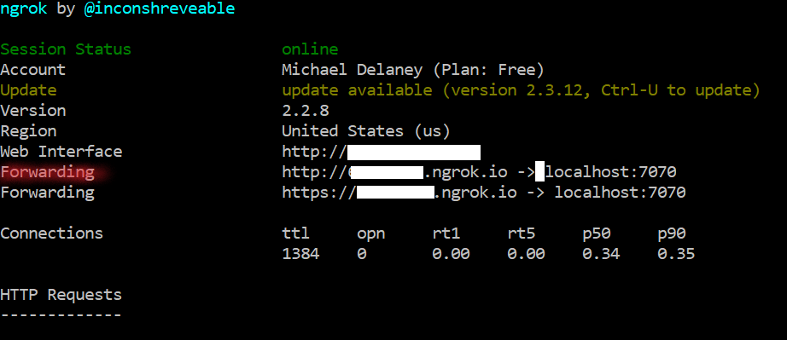
- Now you will need your port number from Blue Iris that you wrote down earlier. In Ngrok type the following (I’m using port 8081 but yours may be different).
ngrok http 8081
This should put your service online and show you something similar to the following: (my addresses are whited out)
You will want to leave Ngrok running now and write down the address across from the “Forwarding” in red in the image. You do not need to write down the http// part, just the numbers followed by: .ngrok.io
it will be something like: “12456325.ngrok.io”
- Now you will take all the info we have acquired, open the Blue Iris app on your device, and enter in all the info. The address you got from Ngrok will be entered into the WAN address. Just remember you need to keep Ngrok running and minimized as well as Blue Iris in order to view the cameras remotely.
- If your computer restarts or you close out of Ngrok for any reason, double click the Ngrok program again to open it and follow step 14 again. It will give you a new address that you will need to re-enter into your Blue Iris app.
- ENJOY!!

